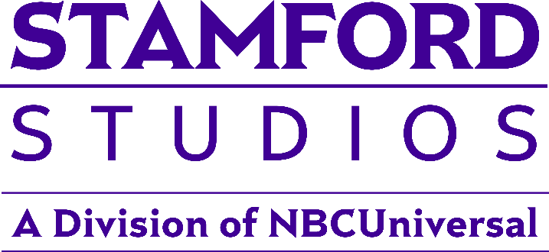

STAMFORD STUDIOS CELEBRATES ITS 15TH ANNIVERSARY

Multifaceted Production Studio Opened Its Doors In 2009 and Is Home to “The Steve Wilkos Show” and “Karamo”

STAMFORD, Conn – Nov. 18, 2024 – NBCUniversal’s Stamford Studios, the full-service production facility located in the heart of Downtown Stamford, is celebrating its 15th anniversary. Since 2009, Stamford Studios has been a premier television and video production studio in the tri-state area and ushered in a new wave of entertainment by producing such iconic daytime talk shows as NBCUniversal Syndication Studios’ “The Jerry Springer Show” and “Maury,” and currently “The Steve Wilkos Show” and “Karamo.”

“In 2009, we took a leap of faith in relocating our established talk shows to the wonderful community of Stamford, Conn., building a state-of-art facility that infused new energy into the production of the shows as well as our iconic hosts,” said Tracie Wilson, Executive Vice President, NBCUniversal Syndication Studios & E! News. “I’m so grateful and proud of our extremely dedicated team at Stamford Studios, all of whom are the driving force behind our 15 years of success. We invite productions from all corners of our industry to come check out the magic."

Located within the New York metropolitan area, the 46,000-square-foot production center offers two soundstages, state-of-the-art HD control rooms, support space featuring an oversized production office, 10 greenrooms, talent dressing rooms, hair and makeup rooms, wardrobe closets, oversized audience holding area, 24/7 security and easy access to several downtown municipal parking garages.

"We are thrilled to be celebrating our 15th anniversary right here in the heart of Downtown Stamford,” said Vinnie Fusco, Senior Vice President, Production and Operations, NBCUniversal's Syndication Studios, Stamford Studios and Terrace Studios. “This milestone is a testament to the incredible team that we've built here at Stamford Studios and the loyal community that supports us. We look forward to continuing that partnership and our role as a major and vital part of this media production community that originally moved to Connecticut to take advantage of the Connecticut state film, TV and digital media tax credit.”

“Fifteen years ago, we had a vision of transforming Stamford’s former Rich Forum Theater into a production house for our three anchor shows – “Maury,” “The Steve Wilkos Show” and “The Jerry Springer Show” – and we achieved that and much more,” said Kristen Killackey, Vice President of Production and Operations, NBCUniversal's Syndication Studios, Stamford Studios and Terrace Studios. “As we look toward the future, we hope to become a home to other productions and continue the legacy we have started of producing innovative and captivating television.”

Additionally, with the recent opening of a state-of-the-art digital studio, aptly named the Digital Factory, the facility now offers production space for all forms of digital media, including a podcast studio, photography studio, green screen capabilities, live streaming and much more.

Stay connected by following Stamford Studios on Instagram, Facebook and LinkedIn. For more information, please visit Stamford Studios at StamfordStudios.com

For videos and photos of Stamford Studios and the Digital Factory click HERE

ABOUT STAMFORD STUDIOS
Stamford Studios’ rich entertainment history spans much further than its 14 years as a film and television production facility. The historic Stamford Theater once stood at the corner of Tresser Blvd and Atlantic St. Built in 1915, the Stamford Theater began as a movie house before becoming the original location for the Stamford Center for the Arts, a non-profit cultural arts organization focused on entertaining and educating the people of Stamford, CT. For over 75 years, the Stamford Theater welcomed countless musicians, shows, and stars, providing the residents of the greater Stamford area a haven for the arts. In 1992, the Stamford Theater closed its doors but was replaced by the Rich Forum Theater, which continued to be one of the two campuses of the Stamford Center for the Arts. The Palace Theater serves as the other campus, located just down the street. Originally opening in 1927, the Palace Theater was originally a beautifully designed vaudeville house. Then, after it was restored in 1983, it became a live theatre and concert venue. As part of the Stamford Center for the Arts, the Rich Forum Theater was known for its high entertainment quality in the performing arts sphere. Stamford Studios continues that tradition today, albeit through a different component of the entertainment industry. After the renovations in 2009, Stamford Studios became a premiere television and video production studio and ushered in a new wave of entertainment in Stamford housing “The Jerry Springer Show,” “Maury,” “Judge Jerry,” “Trisha,” and “Crazy Talk.” Today the studio serves as the home for shows such as “The Steve Wilkos Show” and “Karamo,” but also has housed countless pilots and other productions. Stamford Studios is proud of its entertainment history and continues to be a staple of the arts throughout the industry.

ABOUT NBCUNIVERSAL SYNDICATION STUDIOS
NBCUniversal Syndication Studios is responsible for the production, sales, and distribution of NBCUniversal products to broadcast television within the United States. The division develops and produces first-run programming and distributes these shows, along with off-network content, in broadcast television as well as digital and streaming platforms. First-run broadcast syndicated programming includes “Access Hollywood,” “Access Daily with Mario & Kit,” “The Kelly Clarkson Show,” “Karamo,” “Maury” and “The Steve Wilkos Show.” Current first-run original productions include “American Anthems,” a music-based docuseries for PBS; “Billion Dollar Babies: The True Story of Cabbage Patch Kids,” a documentary that premiered at Tribeca Film Festival in 2022 and now available on Amazon. In addition, the division distributes the retro television broadcast network Cozi TV, the weekend syndicated series “Open House” and “Judge Jerry” on Nosey.com. Current off-network programming includes “Chicago Fire,” “Chicago P.D.,” “Dateline,” “Law & Order: Special Victims Unit,” and “Suits.”

Media Inquiries:
Sara.Paige@nbcuni.com
Molly.Zwiren@nbcuni.com

Stamford Studios/Facility Inquiries:
Vinnie.Fusco@nbcuni.com
Nova.Calise@nbcuni.com

